Lesson 5 Demo 7: Run a Container into a Running Service Under Swarm

This section will guide you to:

* Run a container into a running service under swarm

**Step 1:** Run the **nginx** image as a service in **global** mode, on each node in the swarm cluster

*sudo docker service create --mode global *

*--publish mode=host,target=80,published=8080 *

*--name=nginx nginx:latest*

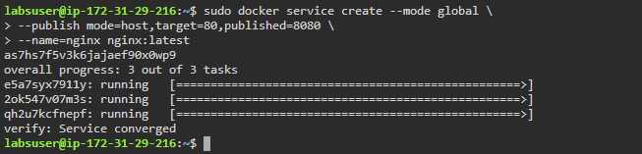

**Step 2:** Create a **nginx** service running three replica containers on the swarm cluster

*sudo docker service create *

*--name my_web --replicas 3 *

*--publish published=5050,target=80 nginx*

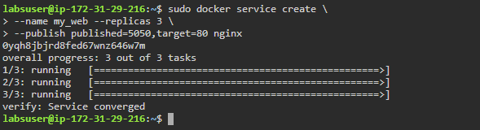

**Step 3:** Check the status of each container instance running within the service:

*sudo docker service ps my_web*

